
Malnad College Of Engineering
Under the auspices of M.T.E.S ®

(An Autonomous Institution Affiliated to VTU, Belgaum)

P.B. No. 21, Hassan 573 202, Karnataka

Cryptography, Network security and Cyber law (23IS601) TOPIC :- “AI based fake job offer detection”
Submitted By:

Name | USN
A S Nishanth | 4MC23IS001
Chethan H R | 4MC23IS024
Harish H R | 4MC23IS038
Jeevan H K | 4MC23IS049

Under The Guidance of:

Dr. NANDITHA B R

(Professor)
Dept of ISE
Department of Information Science and Engineering
Malnad College of Engineering
Hassan - 573 202
2025-2026

Abstract
Fake Job Offer Detector is an AI-based web application developed to help users identify fraudulent job postings and recruitment scams. The project focuses on providing a secure and reliable platform that analyzes job offers using machine learning and modern web technologies. The system is built using React for the frontend, Node.js and Express for backend services, Firebase for authentication and database management, and AI-based detection techniques for identifying suspicious job-related activities. Users can verify job offers, check company legitimacy, analyze suspicious messages, and receive fraud detection results through a responsive user interface. The platform ensures secure access using JWT authentication and Firebase Authentication mechanisms. Intelligent analysis helps detect fake recruiters, scam links, unrealistic salary offers, and phishing attempts, thereby improving user safety and awareness. The application follows a scalable architecture that supports efficient handling of user requests and fraud detection processes. The Fake Job Offer Detector demonstrates the practical implementation of artificial intelligence and full-stack web development concepts in solving real-world cybersecurity problems. The project aims to provide a reliable, scalable, and user-friendly solution for detecting fake job offers and protecting job seekers from online recruitment fraud.

INDEX

Section | Content | Page_number
1 | Introduction | 1
2 | Objectives | 2
3 | Problem statement | 2
4 | System overview | 3
5 | System architecture | 3-4
6 | Working of the system | 4
7 | User Roles and Access Control | 5-6
8 | Key Features | 6-7
9 | Security and Privacy | 7-8
10 | Advantages of the System | 8-9
11 | Screenshots | 9-11
12 | Conclusion | 12

Introduction

In today’s digital era, online job portals and recruitment platforms have become one of the most widely used mediums for employment opportunities and career growth. However, traditional online recruitment systems often face major challenges such as fake job postings, fraudulent recruiters, phishing attacks, and misuse of personal information. As the number of online job seekers continues to increase rapidly, there is a growing need for intelligent and secure systems that can identify fraudulent job offers and protect users from recruitment scams effectively. The increasing rise in cybercrime related to employment fraud highlights the importance of developing scalable and reliable AI-based solutions that can analyze suspicious job postings, detect scam patterns, and provide a safer job-searching experience for users.

To address these challenges, this project introduces an AI-based Fake Job Offer Detector system that combines modern web technologies with intelligent fraud detection techniques to improve online recruitment safety and reliability. In this system, user information, job posting details, verification records, and fraud analysis data are managed using backend services and cloud databases, while suspicious job-related content is analyzed using machine learning and AI-based detection mechanisms. The system efficiently identifies fraudulent activities such as fake recruiters, phishing links, unrealistic salary offers, and scam job postings by analyzing patterns and user inputs. Cloud-based integration helps in secure data storage, fast processing, and scalable performance across different devices and platforms. This intelligent approach reduces the risk of online recruitment fraud, improves user trust, and enhances overall system efficiency in detecting and preventing fake job offers.Additionally, the platform is designed with secure authentication and user management features to ensure safe access to content and user data. Registered users can upload videos, view content, like videos, and manage watch history, while administrators can monitor and manage platform activities efficiently. Security measures such as encrypted communication, secure authentication mechanisms, and controlled access to resources help maintain data privacy and platform reliability. The system also supports responsive design, efficient search functionality, and smooth video playback, making it suitable for modern digital entertainment and educational applications. demonstrates the practical implementation of cloud computing and fullstack web development in creating a secure, scalable, and user-friendly video streaming platform. The project highlights how cloud- based technologies can transform traditional media sharing systems into efficient digital platforms that improve accessibility, user engagement, and content delivery performance.

Objectives

The main objectives of this system are:

  - To develop and manage an AI-based fake job offer detection platform

  - To securely analyze, verify, and detect fraudulent job postings efficiently

  - To provide authenticated access for users and administrators

  - To ensure accurate fraud detection and reliable verification performance

  - To enhance platform security and user data protection

  - To improve user experience through responsive and interactive featuresatures

Problem Statement

Fake job offer detection systems often face challenges such as:

  - High risk of fraudulent job postings and fake recruiter activities

  - Difficulty in verifying and analyzing suspicious job offers efficiently

  - Lack of scalability in traditional job verification systems

  - Performance issues such as delayed detection and inaccurate verification

  - Security risks related to user data and personal information

These challenges highlight the need for a secure, scalable, and efficient platform that can manage, store, and deliver video content smoothly across different devices and network conditions.

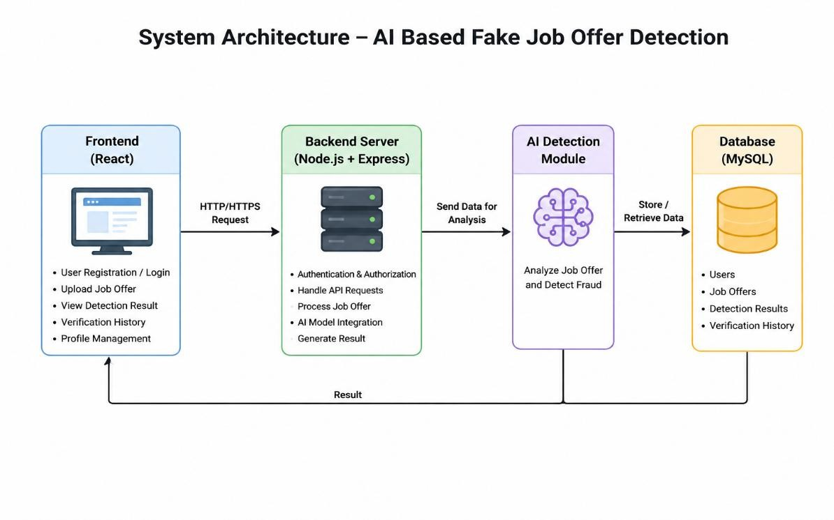
System Overview

Figure 1 : System Overview

System Architecture

The architecture follows a three-tier model:

  - Presentation Layer

    - User interface (web or mobile)

    - Allows login, upload, and viewing of records

  - Application Layer

    - Backend server

    - Handles authentication, file uploads, and data processing

  - Data Layer

    - Database for structured data
    - Firebase for storing user records

Working of the System

- User Authentication: Users log in using secure authentication credentials.
- Job Upload: Users or administrators upload job details through the platform int
- AI Integration: Job details are analyzed and verified securely using AI-based services.
- Result Storage: The system generates verification results which are stored in the database.
- Content Retrieval: Job records can be searched and filtered using categories, titles, or user preferences.
- Data Retrieval: Records can be searched using filters like company name, recruiter ID, or job role.

Key Features

The system offers a comprehensive set of features designed to improve security, accuracy, and usability in detecting fake job offers and recruitment fraud. These features are categorized into basic, advanced, and interactive capabilities.

  - User Registration and Profile Management

Allows users to create, edit, and manage their personal accounts.

    - Includes profile information, verification history, and personalized preferences.

  - Job Verification and Fraud Detection

Enables users or administrators to upload and analyze job-related information efficiently.

    - Users can securely verify job offers and detect suspicious activities across different platforms.

  - Verification History and User Interaction

Users can view previously verified job offers and continue their verification activities.

    - Interactive features such as fraud alerts and report options improve user engagement.

  - Role-Based Access Control (RBAC)

Ensures that only authorized users and administrators can verify, manage, or modify records.

    - Maintains security and controlled access to platform resources and user information.

Security and Privacy
The AI-based Fake Job Offer Detector system implements security and privacy mechanisms to protect user information, maintain system integrity, and ensure secure fraud detection. Since the platform handles job details, recruiter information, and verification history, several security controls are implemented.

  - User Authentication and Authorization

The system uses secure authentication to control access.

    - Users must log in before accessing features
    - Authentication prevents unauthorized access
    - RBAC provides separate permissions for users and administrators
    - Secure session handling improves reliability

  - Data Protection and Storage

The system securely stores user records and verification history.

    - User information is protected from unauthorized access
    - Sensitive records have access restrictions
    - Job verification reports are securely maintained
    - Detection history is safely preserved

  - Secure Communication

Secure communication is maintained between frontend and backend.

    - HTTPS protects data transmission
    - Secure APIs reduce interception risks
    - Encrypted transfer improves confidentiality

  - AI-Based Fraud Detection

The AI module identifies suspicious activities such as:

    - Fake recruiter profiles
    - Suspicious job descriptions
    - Phishing links and malicious URLs
    - Unrealistic salary offers

  - Privacy Protection

User privacy is maintained during system operations.

    - Personal data access is limited to authorized users
    - Verification history remains private
    - Data collection is limited to fraud detection purposes

  - API and Backend Security

Backend services include additional protection mechanisms.

    - Input validation prevents invalid data
    - Protected APIs improve access control
    - Error handling reduces information leakage
    - Rate limiting prevents misuse

  - Monitoring and Logging

Monitoring helps maintain security.

    - Detection activities are recorded
    - Logs help identify suspicious actions
    - Administrators can monitor system usage

  - Security LimitationsSome limitations still exist:

    - AI accuracy may vary in complex cases
    - False detection may occur
    - Continuous updates are required for new scam patterns
    - Internet dependency affects availability

Advantages of the System

Centralized Data Storage

- All video content and user-related information are managed through a single.

- Eliminates content duplication and improves consistency in media management.

Easy Accessibility from Anywhere

- Users can securely access and stream videos from any location with internet connectivity.

- Supports seamless viewing experience across desktops, tablets, and mobile devices
Reduced Paperwork

- Cloud-based media storage minimizes the need for maintaining large local servers and storage systems.

- Reduces infrastructure complexity, maintenance effort, and operational costs..

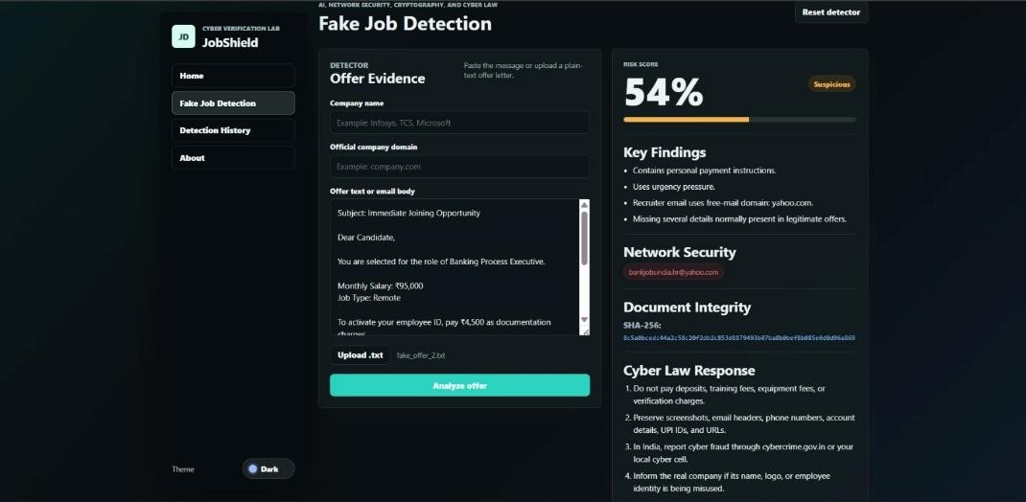
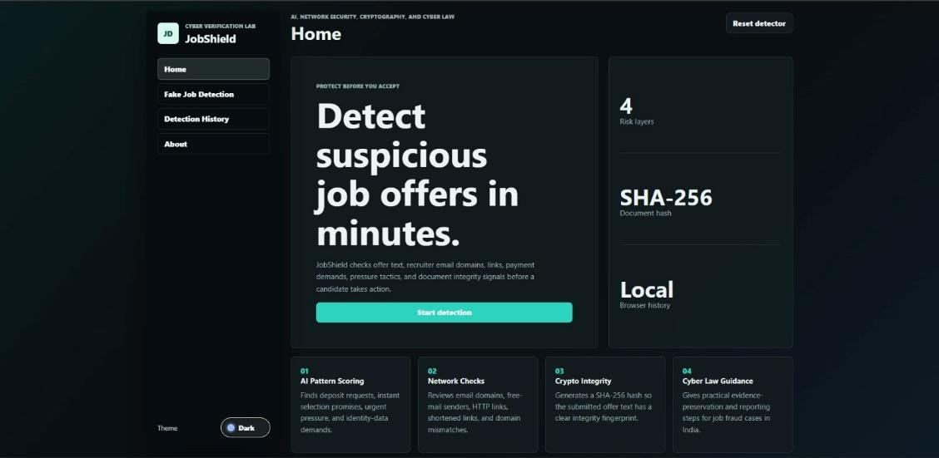
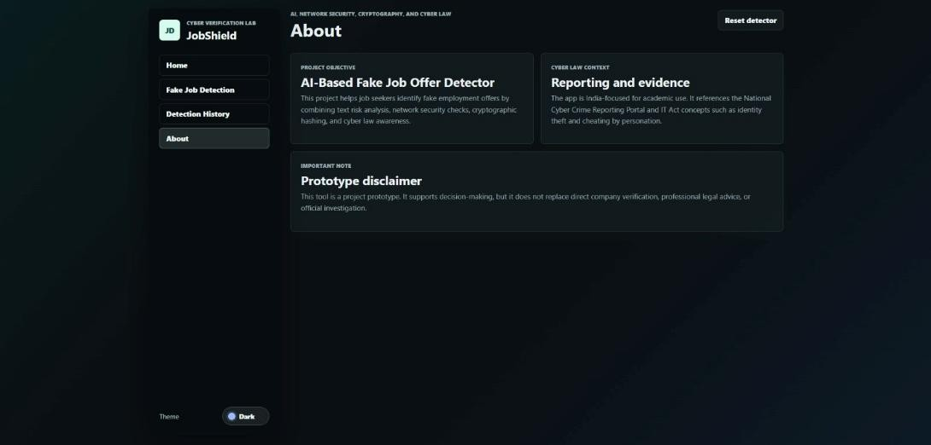
Screenshorts

Figure 2.1 : User Authentication Page

Figure 2.2 : Homepage Interface

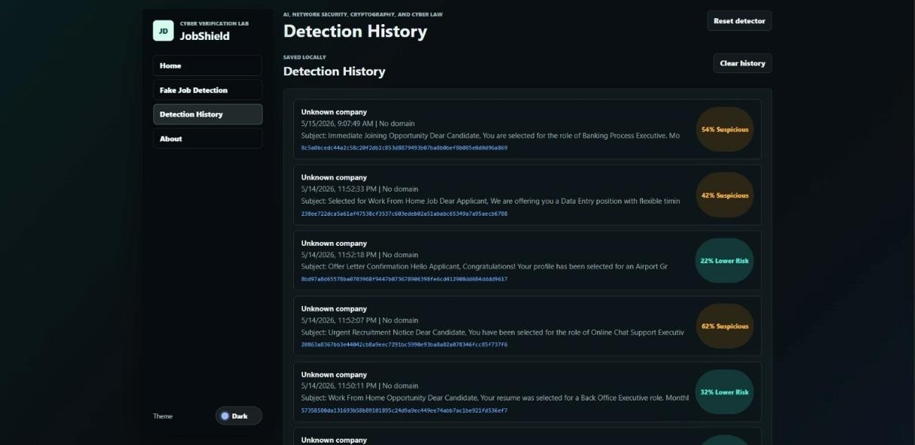
Figure 2.3 : Uploading offer letter

Figure 2.4 : Detection History

11.Conclusion

The AI-based Fake Job Offer Detector system provides a modern solution to the challenges of online recruitment fraud and fake employment platforms. By integrating intelligent fraud detection techniques with a secure and scalable web architecture, the system improves reliability, reduces the risk of recruitment scams, and enhances the overall user experience. Users benefit from accurate job verification, secure data handling, and interactive features such as fraud analysis, suspicious link detection, and recruiter verification, while administrators can efficiently manage job-related data and monitoring services through centralized system controls.

Security and reliability are important aspects of the system’s design. Features such as secure user authentication, protected database storage, optimized API communication, and responsive frontend architecture ensure that user information and verification data remain safe and reliable. The AI-based detection mechanisms further improve fraud identification accuracy and suspicious activity analysis across different platforms and devices, ensuring a stable and efficient user experience.

While the system offers several advantages, certain limitations such as dependence on internet connectivity, limited fraud detection accuracy in complex cases, and reliance on third-party

cloud services must also be considered. With future enhancements like AI-based scam prediction, real-time fraud alerts, advanced recruiter verification, and improved user interaction features, the project can evolve into a more comprehensive and intelligent job fraud detection platform. Overall, the Fake Job Offer Detector demonstrates the practical application of artificial intelligence, modern web technologies, and cloud computing in developing a secure, scalable, and user-friendly recruitment fraud detection system.

